***Project Idea***

Food waste is becoming a larger problem as the years go by. According to [1], about one-third of the world’s food is wasted or lost each year. The same article also pointed out that one of the main reasons of food waste is due to removal of foods that are either reaching or exceeding their expiry dates.

Our team decided to tackle this problem. We chose to expand on a member’s existing idea and create an application with the topic of “smart home”. The main purposes of this app include keeping track of food expiry dates and simultaneously helping the user to reduce food waste by recommending some approachable options for those foods, such as cooking them with suggested recipes. The application will be called *tinyfridge*.

We did some research online and found out that this type of project is quite popular. The need for a solution to food waste at homes is quite substantial. Most people usually fail to keep track of the expiry date of the foods they buy. Sometimes, they just completely forget that they have already had those foods at home, and not until they have bought more do they realize that there is an abundance at home. At the end of the day, most of the times when people encounter this situation, it is almost inevitable that there will be more food wasted.

From a similar project online, we managed to decipher what features users want to see in the app.

In our rough draft for the app, *tinyfridge* consists of a storage section which contains the foods that the users have at home, and a shopping list that takes the user’s input about their grocery buying list. When the user writes down in this list, it will point out what foods they already have based on the storage section. After having bought all the product they need, *tinyfridge* allows them to scan their shopping receipt and the purchase information will be updated to the storage section. Whenever an item is close to its expiry date, *tinyfridge* will send notification as well as the reminder for the user to look at the recipe section to know what to do with the nearly expired item. When the user accesses *tinyfridge*, what will be shown first is a calendar screen. The expiry dates of the foods currently in the storage section will be highlighted along with what item it is.

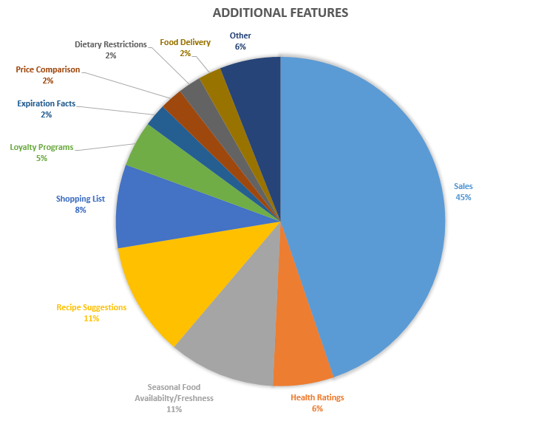

Figure 1 Data on features people would like to see in app

Source: Adapted from [2]

In the future, our also decide to add more features in order to make this app even more beneficial to users. We are considering adding an information section about the prices of foods people usually buy (based on their input) because, according to the figure, people are most interested in knowing how much money they spend on their sustenance. A food availability section also looks promising, although it will be difficult to implement such a feature. We are thinking of adding a health ratings section too, because health is important to users.

Our team believe that this app, if made possible, will change the general bad habits of food waste in our society. It will help people to be more smart with their purchase and avoid wasting food while being able to eat more.